|  |  |
| --- | --- |
| Contents | Page |
| Command line | 1 |
| Command line examples | 4 |
| File permissions and terminologies | 4 |
| File systems | 5 |
| Virtual memory | 6 |
| Causes of segfaults / page faults | 6 |
| C standards | 7 |
| Networks and subnets | 7 |
| IP stack | 8 |
| Network address translation (NAT) | 8 |
| File handling C functions | 9 |
| String handling | 9 |
| Processess | 10 |
| Flags | 10 |
| Process states | 10 |
| Threads and thread safety | 10 |
| Thread states | 11 |
| Mutexes and semaphores | 11 |
| Process and thread diagrams | 11 |
| Signals | 12 |
| Signal handlers | 12 |
| Socket system calls | 12 |
| Operator precedence | 13 |
| ASCII table | 13 |

# Command Line

|  |  |  |
| --- | --- | --- |
| **Command** | **Options** | **Explanation** |
| grep | print lines matching a pattern (grep <string> <filename>) | |
| -v | invert-match: displays lines not containing the string |
| -o | only show part of line that matches pattern |
| -i | case insensitive |
| -R | search all directories |
| $ | e.g. fish$ (looks for the word fish as the last word of a line) |
| ^ | e.g. ^fish (looks for the word fish as the first word of a line) |
| . | any character in regex except newlines |
| * | 0 or more of previous expression in regex |
| gcc | -o | creates an executable file from a c file, the order needs to be:  gcc -o <executable-name> <name-of-file> |
| -c | compiles a c file and creates an .o file of the same name |
| -g | include debugging symbols |
| ls | list directory contents | |
| -l | use a long listing format |
| -a | shows all hidden directories, do not ignore entries starting with . |
| -d | list directories themselves not their content |
| -i | print the index number of each file |
| ps | process status | |
| -e | show all processes -> to see every process on the system using standard syntax |
| -f | do full format listing, adds additional columns |
| sort | write sorted concatenation of all files(s) to stdout (sort <option> <filename>) | |
| -r | reverse result of comparisons |
| -k | sort via key |
| uniq | report or omit repeated lines | |
| -c | count number of occurrences |
| cat | concatenate files to print on stdout | |
| head | output first part of file to stdout; first 10 lines if not specified | |
| -n | output first, N, number of lines (with leading ‘-’ print all but last N) |
| -c | print first N bytes of each file (leading ‘-’ as above) |
| -q | quiet, never print headers giving file name |
| tail | display last part of file to stdout; last 10 lines if not specified | |
| -n | output last, N, number of lines |
| cut | remove sections from each line of files | |
| -f | select only these fields; print any line that contains no delimiter character, unless -s is specified  Can specify multiple fields with a comma (e.g. -f1,3,4 )  Can specify ranges with dashes. N- *Nth onwards*, -M *up to M*, N-M *n to m* |
| -s | do not print lines not containing delimiters |
| -d | specify delimiter (e.g. -d’:’ ) |
| wc | print newline, word and byte counts for each file | |
| -l | number of newlines |
| -c | byte count |
| -m | character count |
| diff | compare files line by line | |
| -q | report only when files differ |
| -s | report identical files |
| svn | subversion command line client tool | |
| commit | send changes from working copy to repository |
| add | put files in directory under version control. Added to repository in next commit |
| remove | remove files and directories from VC. Scheduled for deletion upon next commit and removed from working copy. |
| move | move and/or name something in working copy or repository |
| update | bring changes from repository into working copy |
| info | display information about a local or remote item |
| log | show log messages for a set revision(s) and/or path(s) |
| status | print the status of working copy and files and directories |
| diff | display differences between two revisions or paths |
| chmod | change file modes i.e. change access controls (can’t use if not owner) | |
| u/g/o/a  +/-  r/w/x | user/group/others/all  add/remove  read/write/execute |
| -c | only report when a change is made |
| -R | change files and directories recursively |
| -v | output a diagnostic for every file processed |
| -f | suppress most error messages |
| ls | list directory contents | |
| -l | lists files and read write execute info for each user group and other |
| -i | list index number of each file |
| -s | print allocated size of each file of each file |
| -a | print all files including hidden ones (prefaced with ‘.’) |
| rm | -r | remove directories and their contents recursively i.e. delete everything in the specified subdirectories |
| -f | force -> ignore nonexistent files and arguments, never prompt |
| -d | remove empty directories |
| -v | explain what is being done |
| * | remove all |
| mkdir | make directories (if they do not exist) | |
| -m | set file mode like chmod |
| -p | no error if existing parent, make parent directories as needed |
| rmdir | remove empty directories (if they are empty) | |
| -p | remove directory and its ancestors  e.g. ‘rmdir a/b/c’ i.e. ‘rmdir a/b/c a/b a’ |
| cp | copy files (cp <old> <new>) | |
| -r | copy directories recursively |
| scp | secure copy: (remote file copy) files between host and network | |
| -c | selects the cipher to use for encrypting data, this option is directly passed to ssh(1) |
| mv | move (**rename**) file; rename source to destination OR move source to directory | |
| -f | force; do not prompt before overwriting |
| -i | interactive; prompt before overwrite |
| vim | Vi IMproved, programmers text editor | |
| pico | simple text editor in style of Alpine Composer | |
| less | allows backward and forward movement in a file using arrow keys (i.e. cat with up and down, cat only has down) | |
| ln | makes links between files -s for symbolic -p for physical/hard link | |

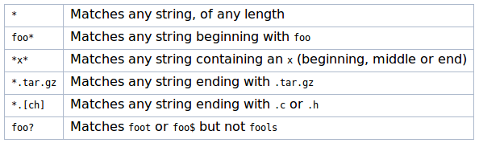

# 

# 

# Command Line Examples

Select the **first and third column delimited by ‘ ‘ and sort by the first**

cat file.txt | cut -d’ ‘ -c1,3 | sort -k1

Get **only** the **12th line** of a given file

cat file.txt | head -12 | tail -1

Get **each line with cat and dog** in a given file

cat file.txt | grep “cat” | grep “dog”

Find **each line** which contains “CSSE1001” and does **not contain the word** “boring”

cat file.txt | grep “CSSE1001” | grep -v “boring”

Find the **number of times** “rowing” occurs **in a given file**

cat ainsley.txt | grep -o “rowing” | wc -l

For **all files** f1,f2,f3 show **all lines containing** “song”, “river” and “terrible”

cat f1 f2 f3 | grep song | grep river | grep terrible

For **all files** g1,g2,g3 show **all lines not containing** “song”, “river” and “awful”

cat g1 g2 g3 | grep -v song | grep -v river | grep -v awful

OR grep -ve grep -ve song -ve awful f1 f2 f3

Find **all lines** in file1 containing the word “dinosaur” and **store in file** called london

cat file1 | grep “dinosaur” > london OR grep dinosaur file1 > london

Show **all lines** in file1 **starting with** W

grep ^W file1

Show **all lines** in file2 **ending with** S

grep S$ file2

Modify path

export PATH = $PATH:newpath

Show second last line of file

cat file | tail -n 2 | head -n 1

Show fifth line of file

cat file | head -n 5 | tail -n 1

Show the third line and later (hide the first two lines)

cat file | tail -n +3

Show all but the last 10 lines (hide the last 10 lines)

cat file | head -n -10

# File Permissions and Terminology

UNIX files user info

**Example** (ls -al)

drwxrwxrwx <number of links> <owner name> <owner group> <file size> <date/time last edited> <name>

**Permissions**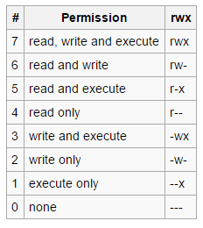

|  |  |
| --- | --- |
| 1st char | ‘-’ is regular file, ‘d’ is directory, ‘l’ is link |
| r | read permission |
| w | write permission |
| x | execute permission |
| - | normal file, or does not have that permission |
| 1st “rwx” triplet | owner permissions |
| 2nd “rwx” triplet | group permissions (owner is member of group) |
| 3rd “rwx” triplet | other permissions (users not in group) |

Chmod commands

Add read+write permissions to user.

chmod u+rw file

Take write+execute permissions from group

chmod g-wx file

Set permissions to group and others for executing only

chmod go=x file

Deny writing permissions to everyone

chmod a-w file

Use numbers for permissions (rwx-w-r-x)

chmod 725 file

**Subdirectories** = number of links - 2

* directories permissions
  + read: can perform ls
  + write: can create files
  + execute: can access that directory
* file permissions
  + read: can view files
  + write: can write to file
  + execute: can run/execute program or script

**Mounting**

* Allows additional file system to be added at a particular entry point of the current file system. Allows you to have more than one file system.
* Takes on a tree like structure

**Symbolic (soft) links**: ln -s <existing> <desired link> **n.b. file does NOT have to exist**

* If the file being pointed to changes, the link will break
* If the softlink is renamed, this will cause issues (as they don’t share an i-node as an identifier)

**Hard links**: ln <existing> <desired link> **n.b. file MUST exist**

* share the same i-node (column 1 in ls -li)
* **ln can fail** because:
  + i-nodes aren’t shared between different file systems
  + incorrect permissions e.g. don’t have permissions on that directory
  + something already exists with that name
  + some systems do not allow cyclic links of directories
  + cannot hard link files belonging to other users

# File Systems

* i-node
  + lots of overhead: not good for lots of very small files
  + array of block ptrs for every file
  + there is a file size limit
  + quicker for accessing parts of files: O(1) -> lots of seeks
* linked list
  + copes better with lots of large files
  + no file size limit
  + no external fragmentation
  + faster sequential access but overall slower reading: O(n) -> lots of seeks further in

Fragmentation

* Internal: space allocated but not used eg: 4KB blocks, 5KB file = 2 blocks, 3KB wasted.
* External: unallocated spaces: too small to be useful, or too spread out.

Linked Systems File Size

* **keep units consistent**
  + n kB = n*10241 bytes = n*210 bytes
  + n MB = n*10242 bytes = n*220 bytes
  + n GB = n*10243 bytes = n*230 bytes
* **number of ptrs in block** = block size / block pointers
* A = size of direct = (num of direct ptrs) * (block size)
* B = size of indirect = (num of indirect ptrs) * (number of ptrs in block) * (block size)
* C = size of double indirect = (num of double indirect ptrs) * (number of ptrs in block)**2** * (block size)
* **total file system size** = A + B + C
* **number of blocks required to store files** = 1 for inode + number of direct blocks required
  + if size > A, then add number of blocks required in B + 1
  + if size > (A + B), then number of blocks required in C + number of indirect blocks required + 1

# Virtual Memory

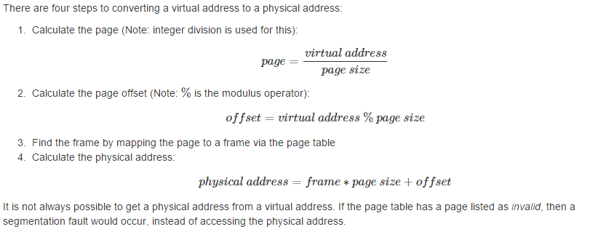

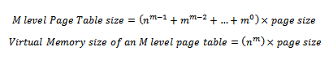

Causes of Segmentation Faults

* when you dereference NULL pointer
* trying to use/point to memory that has not been allocated or has already been freed
* reading or writing to memory you don’t have access/write permissions to
* memory is owned by another process
* being a shitty programmer i.e. because you made it happen
* because quicksand

Causes of Page Faults

* doesn’t exist in TLB (translation lookaside buffer) -> special fast-lookup cache for fast memory access
* when process/object is on disk but not in memory

# C Standards

**General Comments/Notes**

* the C system does not control how memory is used
* does NOT supported nested functions
* avoid global variables except for signal handlers
* **integer math is closed**
  + int/int = int however float/int = float
* no function reloading
* sizeof(char) = 1 (byte); sizeof(int) = 4 (bytes) usually
* reads from right to left
  + a = b = c = 0
* passed by value
* c files compile; o files link
* 0 is false, anything else is true

**ANSI i.e. C90**

* must declare variables before statements
* can initialise inside the braces of a for or while loop, but cannot declare.
* boolean is NOT a type, but can be typedef-ed
* no single-line comments allowed, only block comments

**C99**

* booleans is a valid type “bool” #include <stdbool.h>

**Flags**

* -**Werror**: make all warnings into errors
* -**pedantic**: reject all programs that use forbidden extensions
* -**Wall**: all warnings which disgruntled 2310 students consider questionable
* -**Wextra**: extra about constructions that some users consider questionable

# Networks and Subnets

* **network address** = IP addr & subnet mask *(lowest address in network)*
* **host address** = IP addr & -(subnet mask)
* **broadcast address** = IP addr | -(subnet mask) *(highest address in network)*

All Possible Subnet Masks and Example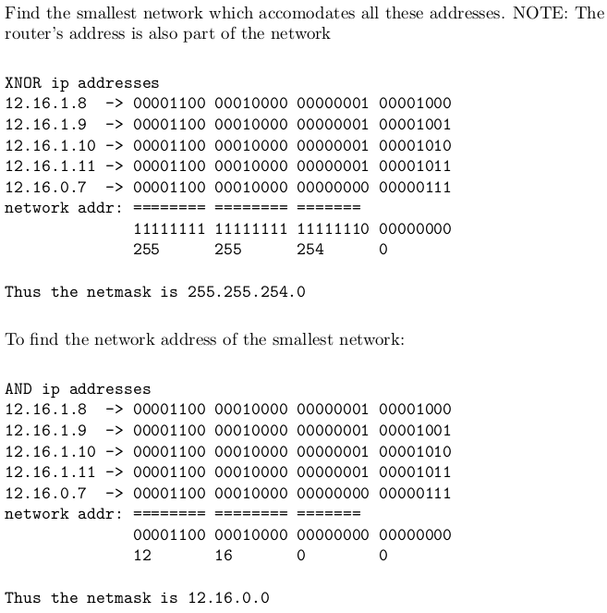

|  |  |  |  |
| --- | --- | --- | --- |
| **Mask** | **bit conversion** | **# networks** | **# hosts** |
| 255 | 1111 1111 | 256 | 1 |
| 254 | 1111 1110 | 128 | 2 |
| 252 | 1111 1100 | 64 | 4 |
| 248 | 1111 1000 | 32 | 8 |
| 240 | 1111 0000 | 16 | 16 |
| 224 | 1110 0000 | 8 | 32 |
| 196 | 1100 0000 | 4 | 64 |
| 128 | 1000 0000 | 2 | 128 |
| 0 | 0000 0000 | 1 | 256 |

*Note: “usable” # of hosts is 2 less due to network and broadcast addresses*

# IP stack

|  |  |
| --- | --- |
| Layer | Examples |
| Application (5) | SSH, HTTP, bittorrent, skype, FTP, Telnet (uses TCP), netcat (uses TCP & UDP), URL  **socket** = IP address + port |
| Transport (4) | **TCP** - transmission control protocol  delivery is reliable and in order  **UDP** - datagram protocol  connectionless and unreliable  **port** and **port numbers**:one interface has 65535 ports but a single IP |
| Network (3) | communicating with any host on the internet  **two tasks**: 1) find node close to destination 2) send packet in that direction (**routing**)  protocol = **IP address**  n.b. different link layers have different rules  ethernet interface needs MAC address + >= 1 IP address |
| Link (2) | talking to nodes without intermediary e.g. ethernet, wifi, infrared, carrier pigeon  need **MAC** (medium access control) **addresses**  **node**: can have a number or link layer interfaces but you don’t always need a node  127.0.0.1 = loopback address |
| Physical (1) | medium through which signal travels e.g. air & EM waves, voltage & wire |

Network Address Translation (NAT)

* a way of dealing with private IP addresses so the internet does not run out of IVP4 addresses
* when num of IP’s assigned to you is less than total num of computers trying to access internet, assigns entity/organisation in a single IP
* some IP’s are non-routable, this is how they access the internet
* example: only occurs at boundary of UQ to interact with external networks
* n.b. every interface has it’s own IP address

Gateway Address

* idea: there is a local network and everybody else, to talk to everybody else must use a gateway
* gateway: usually 1:1
* router: usually 1:N

Domain Name System (DNS)

* hierarchical naming system that maps names to IP addresses
  + this is how you get to google.com etc

# 

# 

# File Handling Functions

|  |  |  |
| --- | --- | --- |
| **function** | **return value** | |
| **on success** | **on failure** |
| fopen | file pointer | NULL pointer |
| fclose | 0 | EOF |
| fflush | 0 | EOF |
| scanf | number of input items successfully matched | EOF (i.e. -1) |
| fgetc, getc, getchar | unsigned char cast to an int (i.e. not a character) | EOF (i.e. -1) |
| gets, fgets | string read | NULL on error or when EOF occurs |
| ungetc | character | EOF (i.e. -1) |
| fputc, putc, putchar | unsigned char cast to an int (i.e. not a character) | EOF |
| puts, fputs | non-negative number | EOF |
| fprintf | number of characters printed excluding ‘\0’ | negative value returned |

# String Handling

#include <string.h>

|  |  |  |
| --- | --- | --- |
| Function and Description | | Return Value |
| int **strcmp**(const char *s1, const char *s2);  compares the two strings s1 and s2  int **strncmp**(const char *s1, const char *s2, size_t n);  compares the only first (at most) n bytes | | int < 0 if s1 < s2  int = 0 if s1 = s2  int > 0 if s1 > s2 |
| char \***strcpy**(char *dest, const char *src);  copies the string pointed to by src, including the terminating null byte ('\0'), to the buffer pointed to by dest  char \***strncpy**(char *dest, const char *src, size_t n);  at most n bytes are copied | | a pointer to the destination string dest |
| char \***strcat**(char *dest, const char *src);  appends the src string to the dest string, overwriting the terminating null byte ('\0') at the end of dest, and then adds a terminating null byte  char \***strncat**(char *dest, const char *src, size_t n);  If src contains n or more bytes, strncat() writes n+1 bytes to dest (n from src plus the terminating null byte). Therefore, the size of dest must be at least strlen(dest)+n+1 | | a pointer to the resulting string dest |
| char \***strtok**(char *str, const char *delim);  breaks a string into a sequence of zero or more nonempty tokens  char \***strtok_r**(char *str, const char *delim, char **saveptr);  thread-safe version. doesn’t use static char* pointer. | | return a pointer to the next token, or NULL if there are no more tokens |
| char \***strstr**(const char *haystack, const char *needle);  finds the first occurrence of the substring needle in the string haystack. The terminating null bytes ('\0') are not compared | | a pointer to the beginning of the substring, or NULL if the substring is not found |

# Processes

|  |  |
| --- | --- |
| Function | Return Value |
| int **pipe**(int pipefd[2]); | on success: 0  on error: -1 |
| pid_t **fork**(); | on success: child_pid to parent, 0 to child  on error: -1 |
| int **dup2**(int oldfd, int newfd); | on success: new fd  on error: -1 |
| int **execl**(const char *path, const char *arg, …, NULL);  int **execlp**(const char *file, const char *arg, …, NULL);  int **execv**(const char *path, char *const argv[]);  int **execvp**(const char *file, char *const argv[]); | only returns on error: -1 |
| pid_t **wait**(int *status); is **blocking call**  pid_t **waitpid**(pid_t pid, int *status, int options); | on success: child_pid  on error: -1 (or if you have no children) |

Flags

* **WNOHANG**: to test if child process has terminated, returns immediately if no child has exited
* **WEXITSTATUS**(status) returns process exit status
* **WIFEXITED**(status) returns true if process exited normally
* **WIFSIGNALED**(status): returns true if child was terminated by signal

Scheduler

* **long term** (job scheduler): selects which processes which should be brought back into the ready queue
* **short term** (CPU scheduler): selects which process should be executed next and allocates CPU

# Process Possible States

* running
* blocked
* ready

# Threads and Thread Safety

#include <pthread.h> & -pthread

|  |  |  |
| --- | --- | --- |
| Function name and description | | Return Value |
| **pthread_t** threadID  threadID type | | n.a. |
| int **pthread_create**(pthread_t *thread, const pthread_attr_t *attr, void *(*start_routine) (void *), void *arg); | | on success 0  on error - error num and contents of thread are undefined |
| int **pthread_join**(pthread_t thread, void **retval);  waits for the thread specified by thread to terminate. If that thread has already terminated, then pthread_join() returns immediately. The thread specified by thread must be joinable | | on success 0  on error - error number |
| int **pthread_detach**(pthread_t thread);  marks the thread identified by thread as detached. When a detached thread terminates, its resources are automatically released back to the system without the need for another thread to join with the terminated thread (function called on a thread so it doesn't need to be joined) | | on success 0  or error - error number |
| void **pthread_exit**(void *retval);  terminates the calling thread and returns a value via retval that (if the thread is joinable) is available to another thread in the same process that calls pthread_join(3) | | does not return to caller |
| pthread_t **pthread_self**(void);  returns the ID of the calling thread, same value as &thread in pthread_create() | | calling thread’s ID |
| int **pthread_cancel**(pthread_t thread);  sends a cancellation request to the thread thread. Whether and when the target thread reacts to the cancellation request depends on two attributes that are under the control of that thread: it’s cancelability state and type | | on success 0  on error - error number |

# Threads Possible States

* ready
* running
* blocked
* terminated -> recycling

**What data is shared?**

* + Global variables: one copy per process
  + Local variables: one copy per thread i.e. registers and stack
  + Static variables: one copy per process

**Semaphores**

* + sem_init(&lock, 0, value); 0 = not shared between processes, value = num of semaphores
  + sem_wait(&lock); - locks/grabs until value < 0
  + sem_post(&lock); - unlocks/releases

**Mutexes**

* + pthread_mutex_init(&lock, NULL);
  + pthread_mutex_unlock(&lock);
  + pthread_mutex_lock(&lock);

# Process and Thread Diagrams

|  |  |
| --- | --- |
| Diagram | Thread or Process? |
|  | This can be either one.  Threads can be reaped by any other thread. Processes can only be reaped by parent. |
|  | This can also be either one. Even though the parent terminates early, the child is then adopted by init and then reaped.  Both threads and processes can be reaped by init. |

# Signals

* SIGKILL (kill -9 pid) **cannot fail**
* **signals can fail** because:
  + pid does not exist
  + user does not have correct permissions
* SIGHUP (1): terminates -> hang up
* SIGTERM (15): terminates -> shut down cleanly
* SIGPIPE: terminates -> write on a pipe with no one to read it

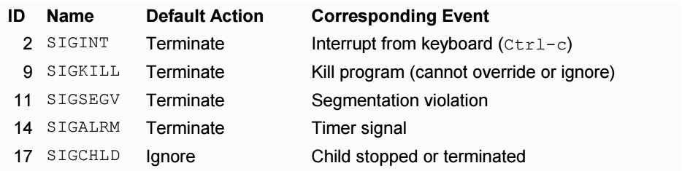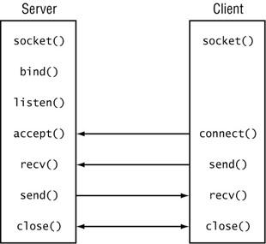

# Signal Handlers

sigaction(int signalNum, struct sigaction* act, struct sigaction* oldact)

struct **sigaction** {

void (*sa_handler)(int);

int sa_flags;

}

# Socket System Calls

#include <sys/types.h>, #include <sys/socket.h>

* why **htons**(), **ntohs**(), **htonl**(), **ntohl**():
  + because endianness of systems doesn’t always match network endianness (big endian)

|  |  |
| --- | --- |
| Function | Return Value |
| int **accept**(int sockfd, struct sockaddr *addr, socklen_t *addrlen);  accepts pending connections for listening socket (sockfd) and creates new connected socket (not in listening state). is a **blocking call** | on success: non-neg file descriptor  on error: -1 |
| int **socket**(int domain, int type, int protocol);  creates a socket as a new communication point |
| int **connect**(int sockfd, const struct sockaddr *addr, socklen_t addrlen);  attempt to establish a connection to a socket given an fd to an address  specify: **SOCK_STREAM** for TCP | on success: 0  on error: -1 |
| int **bind**(int sockfd, const struct sockaddr *addr, socklen_t addrlen);  after a socket is created, bind attaches a local address to it |
| int **listen**(int sockfd, int backlog);  marks a socket to be ready for listening, backlog is max length of pending queue |
| int **getaddrinfo**(const char *node, const char *service, const struct addrinfo *hints, struct addrinfo **res);  **network address translation** service, provide a node and interface (i.e. service) | on success: 0  on error: error code |
| int **getnameinfo**(const struct sockaddr *sa, socklen_t salen, char *host, size_t hostlen, char *serv, size_t servlen, int flags);  converts socket to address to host and service (i.e. port and interface) |
| int **getsockname**(int sockfd, struct sockaddr *addr, socklen_t *addrlen);  returns address of socket | on success: 0  on error: -1 |

# Operator Precedence

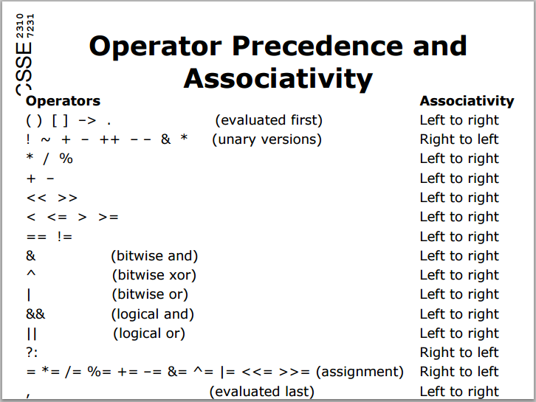

# ASCII TABLE

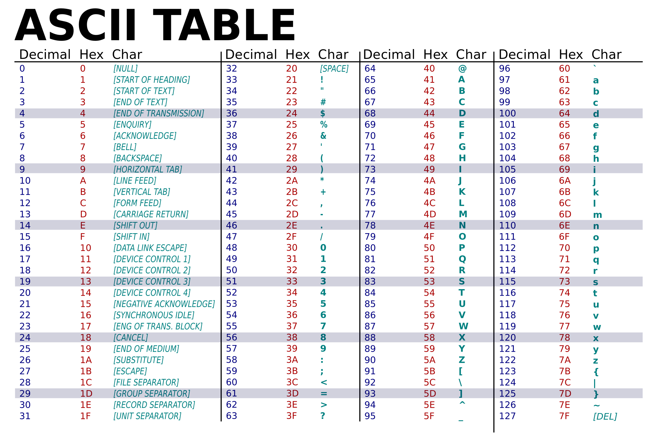

[Source](https://upload.wikimedia.org/wikipedia/commons/thumb/1/1b/ASCII-Table-wide.svg/2000px-ASCII-Table-wide.svg.png)